Alexander Baldree
1/5/26
Module 5.2 Assignment
CSD340

Subject: Tyler Bettis

Questions: 1-10
1. Where were you born and raised?
I was born and raised in Tennessee and have lived here my entire life.
2. How would you describe your personality?
I’d say I’m calm, laid-back, and thoughtful, but I can also be spontaneous when the situation calls for it.
3. What does a typical day look like for you?
Most days are long and exhausting at work, followed by relaxing evenings at home to unwind and reset.
4. What hobbies do you enjoy most?
Gaming, spending time with friends, and anything creative like drawing or art.
5. What is one of your proudest accomplishments?
Winning first place at my 8th-grade art award ceremony.
6. Who has influenced you the most in your life?
My 9th-grade art teacher and my 9th-grade biology teacher.
7. What motivates you?
Thinking about the future and what’s possible.
8. What is a challenge you’ve overcome?
Once being stranded on a boat in the middle of a lake and having to swim and push it to shore.
9. What values matter most to you?
Laughter, friendships, and not giving up on what you start.
10. Do you have a favorite quote or saying?
“You should never give up on what you are trying to accomplish.”

Formal Biography:
Tyler Bettis is someone I’ve known as calm, laid-back, and thoughtful, but also spontaneous when the moment calls for it. He’s a lifelong Tennessean who has spent his entire life in the state, and most of his days are filled with long, exhausting work hours. After work, he usually spends his evenings at home, relaxing and resetting for the next day.
One of the things that stands out most to me about Tyler is his creative side. Art has always been important to him, and one of his proudest moments was earning first place at his 8th-grade art award ceremony. Even though gaming is one of his main hobbies now, he’s talked about wanting to return to art, which shows how much creativity still matters to him.
Tyler is motivated by the future and the possibilities ahead. While he doesn’t have a specific long-term goal he’s working toward right now, he strongly believes in not giving up and staying committed to what you start. That mindset really reflects the kind of person he is.
Two teachers had a big influence on Tyler’s life; his 9th-grade art teacher and his 9th-grade biology teacher. They helped shape his interests and left a lasting impact on him. One challenge he once faced was being stranded on a boat in the middle of a lake, where he had to swim and help push it back to shore. To me, that moment really shows his calm, problem-solving attitude.
More than anything, Tyler values laughter, friendships, and shared memories. He’s known for his dad jokes; like the time he joked about dreaming he was floating in a “Fanta sea”; and his ability to bring humor and positivity into everyday life.

Palette Library:

Typography
- Headings: Montserrat (700, 600)
- Body Text: Open Sans (400, 600)

Color Palette
- Primary Color: #1E3A5F (Deep Navy Blue)
- Secondary Color: #4A90E2 (Soft Blue)
- Accent Color: #F5A623 (Warm Orange)
- Background: #F7F9FC (Light Gray)
- Text: #333333 (Dark Gray)

UI Components
- Buttons: Rounded corners, bold text, primary background, white text
- Cards: White background, soft shadow, rounded edges
- Navigation: Fixed top bar, horizontal menu, bold site title

Layout
- Grid-based card layout for landing and hobbies pages
- Two-column layout for About page
- Clear visual hierarchy using spacing, typography, and color contrast

Wireframe and Description:

Landing Page Wireframe
- Header with navigation
- Hero section: Left text + right portrait image
- Three achievement cards below
- Footer with copyright + external link

About Page Wireframe
- Two-column layout:
  - Left: Portrait image
  - Right: Bio text and quote

Hobbies Page Wireframe
- Page title at top
- Three hobby cards in a grid layout
- Footer at bottom

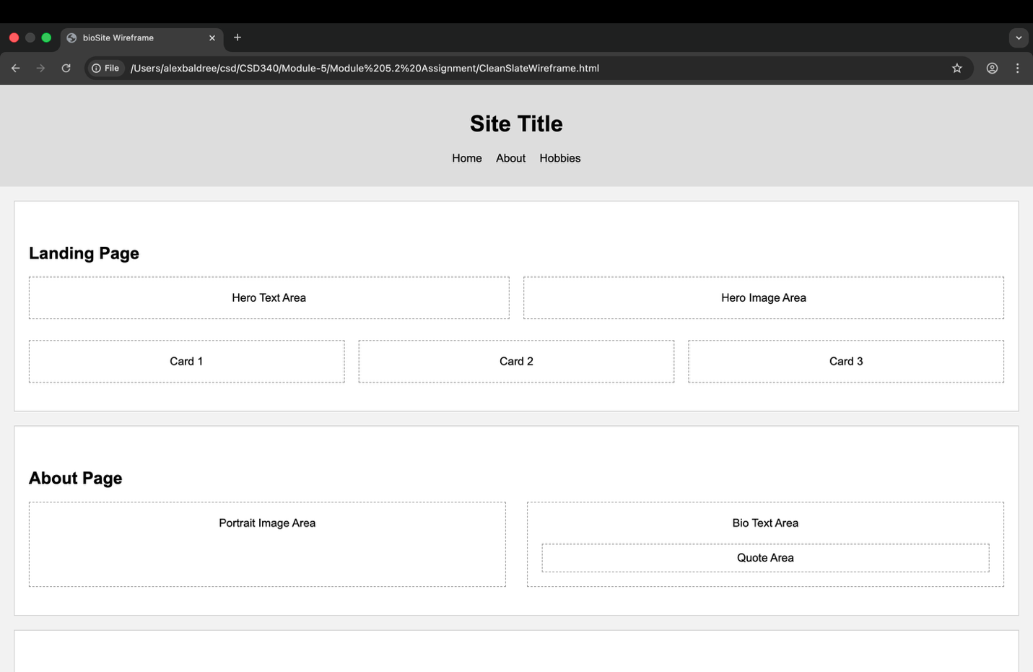
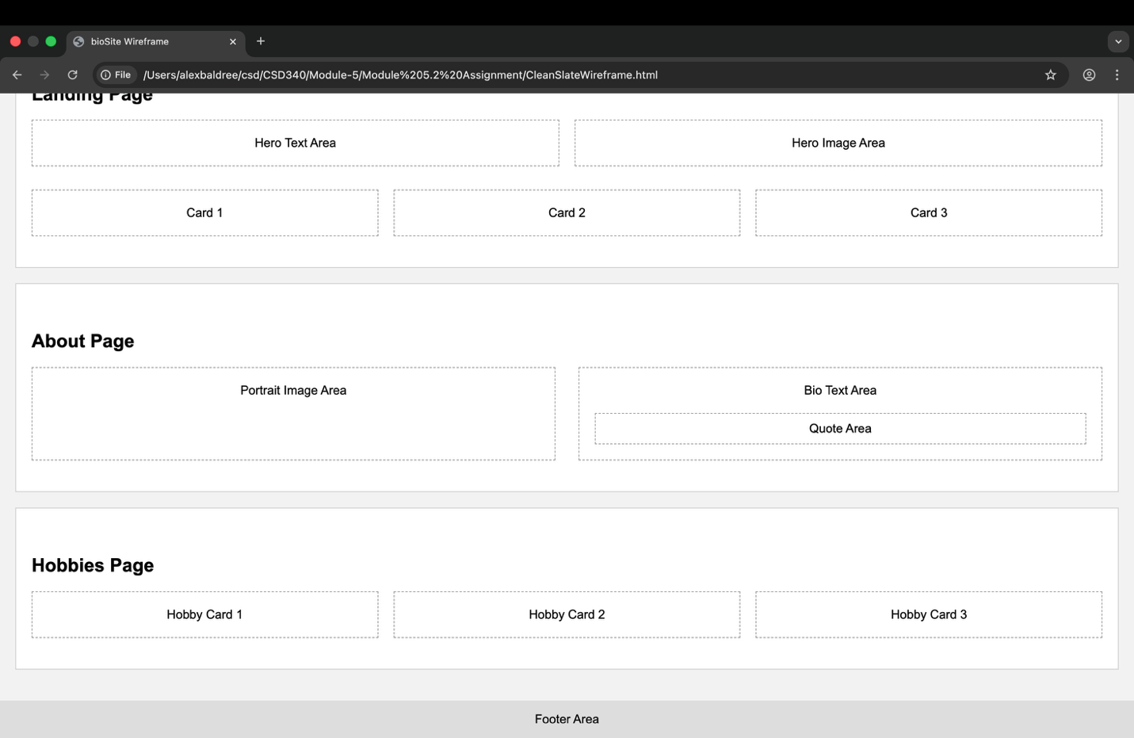

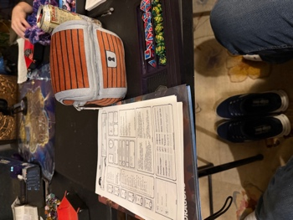 Gaming Image of his setup
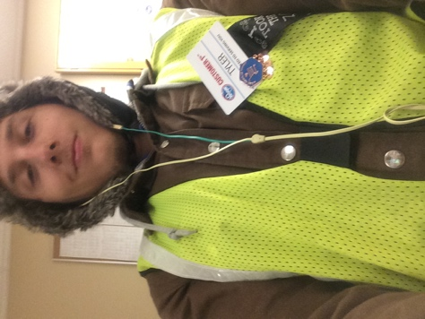 Image of Tyler at work
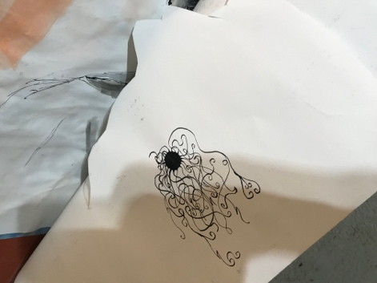 Image of art that he has made
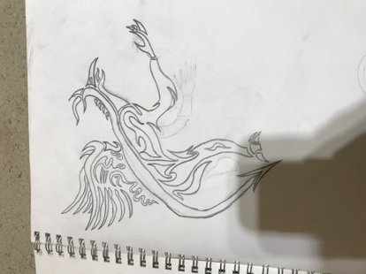 Image of art he made
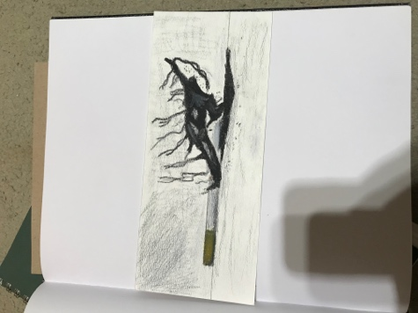 Art made to prevent his mother from smoking
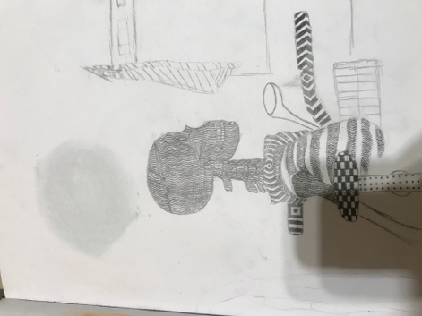 Just some art made by Tyler
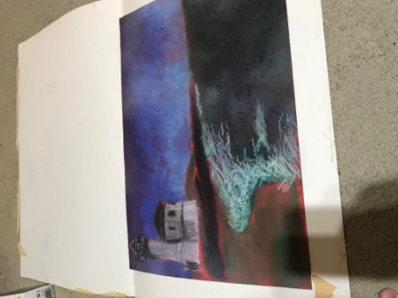 Lighthouse art that won his 8th-grade contest
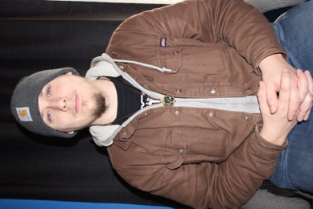 Portrait of Tyler Bettis

